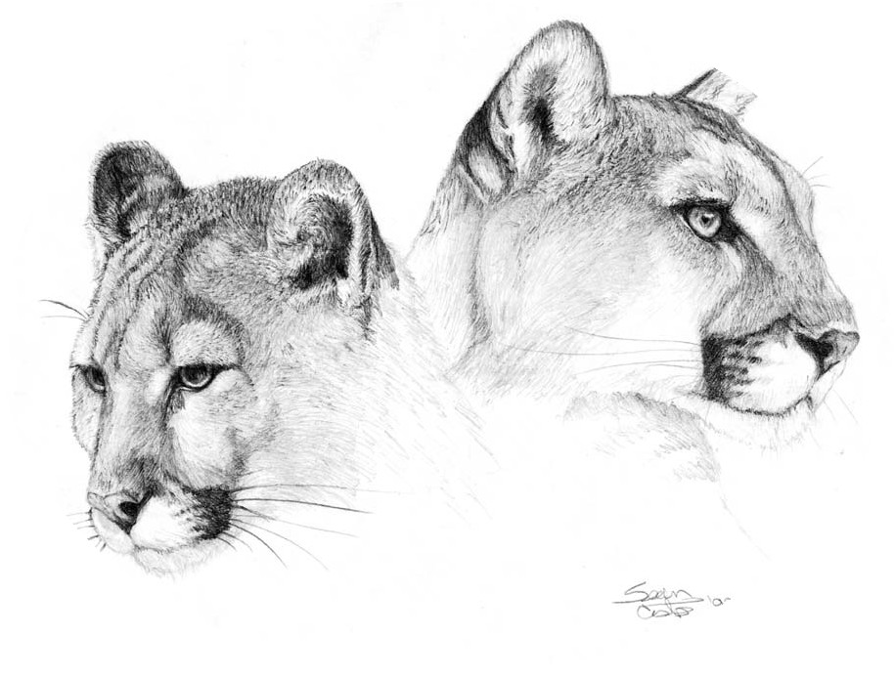McGhee Elementary School
Suggested School Supply Lists
Kindergarten | 1st Grade
2- boxes crayons (24 count)  1- pencil box  1- kid scissors  24- #2 pencils (yellow pencils only)  4- glue sticks (no gel or colored)  2- pink erasers  1- plug in headphones | 2- boxes crayons (24 count)  1- kid scissors  2- glue sticks (no gel or colored)  48- #2 yellow pencils  1- pk. pencil top erasers  2- folders with pockets  1- pencil pouch-no box  8- thin, black dry erase markers  1- plug in headphones labeled w/ name
2nd Grade | 3rd Grade
3- boxes crayons (24 count)  1- pencil box  1- kid scissors  8- glue sticks  48- #2 pencils (sharpened)  2- pink erasers  1- watercolor paints (8 colors)  2- folders with pockets(plastic)  1- old, clean sock  1- spiral notebook(wide ruled)  6- black dry erase markers  2- yellow highlighters | 1- box crayons (24 count)  1- kid scissors  48- #2 pencils (NO MECHANICAL PENCILS)  2- pk. pencil top erasers  8- glue sticks  1- colored pencils  1- watercolor paints (8 colors)  1- ruler  1- spiral notebook (wide ruled)  1- box water base markers  2- folders with pockets  1- pencil box  1- plug in headphones
4th Grade | 5th Grade
1- pencil box  1- scissors  48- #2 pencils (sharpened)  1- colored pencils  1- water based markers  1- watercolor paints (8 colors)  1- box crayons (24 count)  1- plug in headphones  2- black sharpies | 1- box crayons (24 count)  1- 1 inch 3 ring binder  1- pkg. paper (wide ruled)  2- spiral notebooks  1- liquid glue  2- glue sticks  48- #2 pencils(sharpened)  1- colored pencils  1- watercolors (8 colors)  1- folders with pockets  1- scissors  1- ruler (standard & metric measurements)  2- small pencil sharpener  1- plug in headphones  2- blk sharpie  1- pencil box  1- pk binder dividers with tabs (8 count)
2023-2024

